«Display_Name»

Using Blender 2.7 for Animation - **Advanced 7 - Camera Animation (Outdoor Scenic Tour)**

GOAL: Make a camera animation that shows different parts of a scene at different times.

* Open a scene where you can do an outdoor tour. Either open “texture paint landscape,”

OR open a file from any of the Environment folders in R:\Meshes

* File, Save As “3dad7 tour”
* **Add at least 1 object (**File, Import**, Wavefront obj—**if doesn’t appear, try File, Import**, 3dstudio 3ds)** **or character** to your outdoor scene
* **Add at least 3 landscape features** such as hills or lakes using instructions in texture paint tips in the Resources drive if you do not have an island or other landscape that is part water yet.
* Get the camera close enough to show parts of your scene separately—so you see only one of those areas at once (shore, other shore, water, land, mountain, etc).
  + You must have at least **6 keyframes** and **show at least 3 unique areas or objects** in your outdoor scene separately
* Animate the camera to show different parts of your scene, as if you are taking a tour:
  + Change Active Keying Set to Location & Rotation (LocRot):

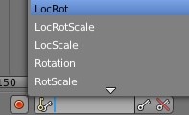

* + Looking through the camera with 0 on the NUMPAD, select the camera by right-clicking on the edge of it so it is orange:

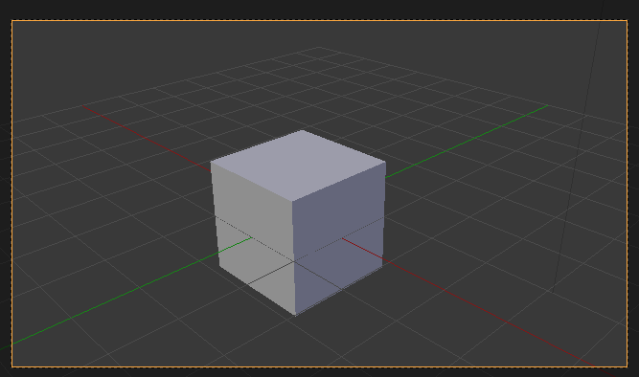

* + Now you can move the camera using these hotkeys (push each key once then let go):
    - **g** then move mouse: uses view x&y to track camera up, down, left, & right
    - **g, z, z** then move mouse: uses camera z to truck camera forward or backward
    - **r** then move mouse: uses view z-axis to spin camera
    - **r, z** then move mouse: pan left or right
    - **r, x, x** then move mouse: tilt camera up & down
  + Once you have the camera where you want to start, then click Insert Keyframe button



* + Go to the next time you want,

& repeat these steps, moving the camera to a different unique place in your scene each time before pushing Insert Keyframe, until you have at least six keyframes like in the picture below:

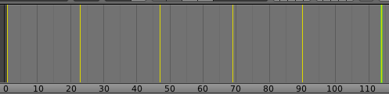

**BONUS: Create an event on your island involving some kind of interaction with people, creatures, or nature**

* Click World button and check Ambient Occlusion



* Click the Render button set your video settings:



* + Change Output path to create the file in your home drive

(such as T:*username*\3dad7 video or H:\3dad7 video) to name the video file (not same as the blend file)

* + Change Encoding to H.264 in order to create a video
  + Click Render, Render Animation